Gillespie Co. Soil & Water Conservation District
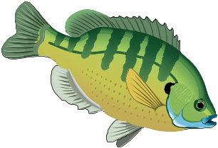FISH SALE

Time to stock your pond or lake!
Place your orders now through April 2nd

FISH SPECIES PRICE
Bluegill Sunfish, 3”- 5" (limited supply) $1.05 each
Red Ear Sunfish, 1”- 3” .80 each
Crappie, 1” - 4” $1.15 each
Largemouth Bass, 1”- 4” $1.15 each
Channel Catfish, 4”- 6” .70 each
Grass Carp, 12” or larger (1-3 lbs. each) * $16.50 each
Minnows (Fathead or Golden Shiners) $13.75 per lb.
Goldfish $12.50 per lb.
* To buy Grass Carp requires a permit from Texas Parks & Wildlife.
Depending on growing conditions between time of hatching & delivery
date, fish size is only guaranteed to be at least the smaller size listed.
If possible, please bring 50 lb. feed sacks for transporting your fish.
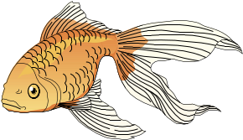

You may place your fish order with:
Gillespie County SWCD, 1906 N. Llano #106
Fredericksburg, TX 78624 - (830) 997-3349 x 3

Orders need to be made and paid for by Monday, April 2nd .
Fish delivery is Friday, April 20th at Gillespie County Fairgrounds.
Programs serve people of all ages regardless of socioeconomic level, race, color, sex, religion, disability, or national origin.

