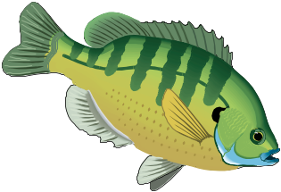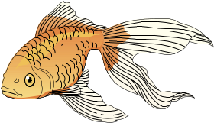Gillespie Co. Soil & Water Conservation District
1906 North Llano Street, #106, Fredericksburg, TX 78624
830-997-3349 ext. 3 phone, 844-496-7937 fax

Fish Order Form for
Friday, September 22 fish delivery at Gillespie County Fairgrounds
Note: Fish need to be paid for before we place the order.
Please make your check payable to Gillespie Co. SWCD. You can mail the order with your payment, or drop it by our office. Please provide your mailing address and phone numbers below, so we can notify you what time to pick up your fish.

Name ________________________________________ Home Phone #__________________________
Mailing Address _______________________________ Cell Phone # ___________________________
City, State, Zip _________________________ Email _______________________________________
NUMBER TOTAL

FISH SPECIES & SIZE ORDERED PRICE DUE

Bluegill Sunfish, 3”- 5" (Limited Supply) . @ $1.05 ea. $

Red Ear Sunfish, 1”- 3” . . . . . . . . . . . . . @ $ .80 ea. $

Crappie, 1”- 4” (limited supply) . . . . . . . . . @ $1.15 ea. $

Largemouth Bass, 1”- 4” . . . . . . . . . . . . . @ $1.15 ea. $

Channel Catfish, 4”- 6” . . . . . . . . . . . . . . @ $ .70 ea. $

Grass Carp (12” or larger, 1-3 lbs. ea.)  _______ @ $16.50 ea. $

Minnows (Fathead) . . . . . . . . . . . . . . . . . . . @ $13.75/lb. $

Minnows (Golden Shiners) . . . . . . . . . . . . @ $13.75/lb. $

Goldfish . . . . . . . . . . . . . . . . . . . . . . . . . . . . . @ $12.50/lb. $
Koi . . . . . . . . . . . .Call for pricing
TOTAL $ __________
 To buy Grass Carp requires a permit from Texas Parks & Wildlife. It could take 4 or 5 weeks to receive the permit once you apply for it. You can get an application at our office, or through Texas Parks & Wildlife via the internet.
Depending on growing conditions from the time of hatching and the delivery date, the size of fish is only guaranteed to be at least the smaller size listed.
If you have clean 50-lb. feed sacks (paper or plastic), please bring them for transporting your fish. The fish are put into plastic bags with water & oxygen, then slipped inside empty feed sacks for protection from the sun during transport to your pond.
Orders need to be made and paid for by Monday, September 11. Fish delivery is on Friday, September 22 at Gillespie County Fairgrounds. We’ll call or send a reminder card for fish pick up.

Programs serve people of all ages regardless of socioeconomic level, race, color, sex, religion, disability, or national origin.

